**FACIAL EXPRESSION RECOGNITION USING AR FACE DATABASE**

**Abstract**

The project offers a thorough investigation into the use of machine learning techniques for facial expression recognition. The main objective is to categorize facial expressions into three groups: angry, smiling, and natural. The Principal Component Analysis and the Local Binary Patterns are two methods used to extract features from images in the AR face databases in order to capture important facial characteristics.

We have applied and assessed five (5) classifiers, such as Artificial Neural Network (ANN), Decision Tree, Naive Bayes, Support Vector Machine (SVM), and k-Nearest Neighbor (k-NN). The accuracy, precision, recall, and results displayed in a confusion matrix are used to evaluate each classifier. The report explores the feature extraction process, how these classifiers are used, and a thorough evaluation of their effectiveness. The results show which classifiers perform best at recognizing facial expressions, providing information about their relative advantages and possible shortcomings.

1. **INTRODUCTION**

The ability of machines to recognize human emotions and react accordingly but accurately is made possible by Facial Expression Recognition, a crucial component of Human-Computer Interaction. Numerous fields, such as entertainment, psychology research, and security can benefit greatly from the widespread applications of this technology. Facial expressions can be used to interpret human emotions, which can help systems become more responsive and intuitive—thereby improving user experience and interaction quality.

The recognition of facial expressions in human-computer interaction is essential to fostering more efficient and natural communication between people and machines. Systems that possess facial expression recognition capabilities can modify their actions according to the user's emotional condition, offering tailored solutions and enhancing user contentment in general. Recognizing a user's happiness or frustration can have a big impact on the effectiveness and outcome of an interaction in virtual assistants and customer service bots.

It is essential to threat detection and surveillance. Security systems can detect unusual behavior or possible threats by analyzing facial expressions, which allows for prompt intervention. This feature is especially helpful in high-security settings like public areas, banks, and airports where keeping an eye on people's emotions can help avert problems before they arise.

It is very helpful in comprehending the feelings and actions of people. It enables researchers to examine nonverbal cues and how they relate to mental states, offering insights into a range of emotional reactions and psychological conditions. By tracking patients' emotional changes over time, facial expression recognition (FER) technology can also help with mental health disorder diagnosis and treatment.

The main goal of this Facial Expression Recognition project is to investigate how machine learning classifiers may be used to distinguish three distinct facial expressions: happy, furious, and natural. The experiment focuses on extracting features from facial photos and assessing the effectiveness of various classifiers using the AR face database. Artificial Neural Network (ANN)Naive Bayes, k-Nearest Neighbors (k-NN), Support Vector Machines (SVM), and Decision Trees are among the five (5) classifiers that have been tested. We also tested it on two (2) additional classifiers which are Random Forest and Logistic Regression.

The dataset used for this facial recognition is the AR face database. It includes pictures of one hundred and thirty-six people, all taken in varied lighting, occlusion, and facial expression scenarios. Because of its variety, the AR face collection is a great tool for developing and evaluating facial expression recognition software. We experiment to create reliable classifiers that can recognize the target phrases under a variety of scenarios by utilizing this dataset.

The project's methodology involves identifying and extracting relevant facial features that contribute to expression differentiation, applying different machine learning algorithms to train models on the extracted features and assessing the classifiers' effectiveness using metrics such as accuracy, precision, recall, and confusion matrices. By following this approach, the project seeks to determine the most effective classifier for facial expression recognition and provide insights into the strengths and weaknesses of each method.

1. **AIM AND OBJECTIVES**

**2.1. To Extract Meaningful Features from Face Images**

* + 1. *Goal*:

Identification and extraction of relevant features that can differentiate between natural, smiling, and angry expressions.

* + 1. *Approach*:

Utilizing modern techniques such as Principal Component Analysis and Local Binary Patterns for Facial Expression Recognition.

* + 1. *Outcome*:

Confusion Matrix of features that highlight essential characteristics of facial expressions.

**2.2. To Implement Various Classifiers for Facial Expression Recognition**

* + 1. *Naive Bayes*:

Stochastic Model known as a probabilistic classifier which classifies the output based on Bayes' theorem.

* + 1. *The k-Nearest Neighbor (k-NN)*:

A clustering algorithm which is non-parametric classifier that uses a trend for majority value distribution of nearest neighbors in the form of clusters.

* + 1. *Support Vector Machines (SVM)*:

Finds optimal hyperplane to separate classes.

* + 1. *Decision Trees*:

This classifier splits data into branches based on extracted feature values.

* + 1. *Outcome*:

Implementation of classifiers ready for training and evaluation.

**2.3. To Evaluate and Compare the Performance of These Classifiers**

* + 1. *Accuracy*:

Percentage of correctly classified instances.

* + 1. *Precision*:

Ratio of correctly predicted positive observations to total predicted positives.

* + 1. *Recall*:

Ratio of correctly predicted positive observations to actual positives.

* + 1. *Confusion Matrix*:

In terms of true positive, true negative, false positive, and false negative, it displays the distribution of data points.

* + 1. *Outcome*:

Performance metrics for each classifier to allow comparison.

**2.4.** **To Analyze the Results and Determine the Most Effective Classifier**

* + 1. *Approach*:

Compare performance metrics, identify strengths and weaknesses, and discuss practical considerations.

* + 1. *Outcome*:

We will select the most effective classifier for facial expression recognition.

1. **THE PROBLEM STATEMENT**

The task at hand involves precisely categorizing face expressions through the extraction of characteristics from photographs. The ratios and separations between particular facial landmarks are examples of these traits. Evaluation is done on how well various classifiers identify these expressions.

1. **METHODOLOGY**

**4.1 Data Set:**

The AR face database includes pictures of one hundred and thirty-six people in various lighting settings and emotions. The face is marked at key locations, from which features are retrieved.

**4.2 Feature Extraction:**

Feature extraction involves the calculation of the specific facial measurements from the (X, Y) coordinates of 22 points in the Image of AR Face Database. These features include:

* + 1. *Eye length ratio*:

The ratio of the horizontal distance of the eyes.

* + 1. *Eye distance ratio*:

The distance between the eyes.

* + 1. *Nose ratio*:

The distance between the nose tip and the eyes.

* + 1. *Lip size ratio*:

The height of the lips.

* + 1. *Lip length ratio*:

The width of the lips.

* + 1. *Eyebrow length ratio*:

The length of the eyebrows.

* + 1. *Aggressive ratio*:

A combined measure indicating aggressive expression.

* 1. **Classifiers Used**
     1. *Naive Bayes Classifier*:

1. Assumes feature independence.
2. It calculates the posterior probability for each class.
   * 1. *The k-Nearest Neighbour (k-NN)*:
3. It classifies the generated output based on the majority label/values of the k closest data points (in the nearest neighbor).
4. Euclidean Distance is being used as the distance metric.
   * 1. *The Support Vector Machine (SVM)*:
5. SVM finds out the hyperplane that best separates different classes.
6. The Kernel trick in SVMs can be useful for non-linear separation.
   * 1. *Decision Tree*:
7. Decision Tree uses a tree-like model containing decisions in each node.
8. It breaks down the data points into smaller sets based on their feature values.

**4.3.5** *Artificial Neural Network*:

1. ANN urges to work like a human brain to process and analyze complex patterns.
2. ANN has multiple layers of nodes connected to each other. These nodes are called as "neurons" and each neuron generates a weighted output of given inputs followed by a non-linear activation function.
3. The model is being trained using backpropagation while adjusting the weights to minimize the error between the predicted value and actual value.
4. **RESULTS**

A confusion matrix, precision, recall, and accuracy were used to assess the classifiers. The outcomes are compiled in the tables below:

**5.1 Accuracy:**

|  |  |
| --- | --- |
| Classifier | Accuracy (%) |
| Naive Bayes | 65.3 |
| k-NN | 65.3 |
| SVM | 68.6 |
| Decision Tree | 56.0 |
| ANN | 77.3 |

Accuracy results in the above table shows that the Artificial Neural Network (ANN) classifier has so far performed best for AR Face Database Images for Facial Expression Recognition by achieving an accuracy of 77.3%. This suggests that ANNs can effectively capture the complexities of facial expressions compared to the other classifiers. The Support Vector Machine (SVM) also performed well with an accuracy of 68.6%, demonstrating its ability to handle the high-dimensional feature space effectively. Naive Bayes and k-NN both achieved identical accuracy of 65.3%, indicating moderate performance. The Decision Tree classifier lagged behind with an accuracy of 56.0%, which may be attributed to its tendency to overfit the training data.

**5.2 Precision:**

|  |  |
| --- | --- |
| Classifier | Precision (%) |
| Naive Bayes | 66.9 |
| k-NN | 69.9 |
| SVM | 77.0 |
| Decision Tree | 63.3 |
| ANN | 80.1 |

ANN has outperformed other classifiers in precision as well by achieving a precision of 80.1% proving its robustness in correctly identifying positive samples. The support vector machine SVM followed the ANN with a precision of 77.0% expelling its strength in minimizing false positive results. The k-NN classifier showed a marginal better precision of 69.9% which is slightly better than Naive Bayes that had a precision of 66.9%. The Decision Tree classifier, with a precision of 63.3%, again showed relatively lower performance.

**5.3 Recall:**

|  |  |
| --- | --- |
| Classifier | Recall (%) |
| Naive Bayes | 65.7 |
| k-NN | 65.4 |
| SVM | 75.2 |
| Decision Tree | 56.8 |
| ANN | 77.5 |

Recall results further highlight the effectiveness of SVM and ANN classifiers. The ANN achieved the highest recall, implying that it successfully identified a significant portion of the actual positive samples. SVM also showed a strong recall at 75.2%, indicating its capability to correctly recognize positive instances. Naive Bayes and k-NN had similar recall values, reflecting their consistent performance across different metrics. The Decision Tree classifier had the lowest recall at 56.8%, further confirming its limited capability in this task.

**5.4 Confusion Matrices:**

**5.4.1** *Confusion Matrix of KNN*:

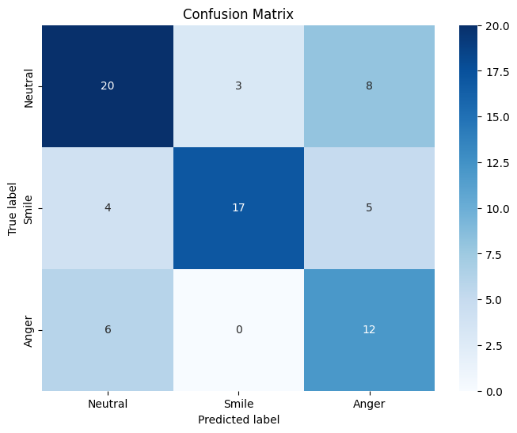

**5.4.2** *Confusion Matrix of ANN*:

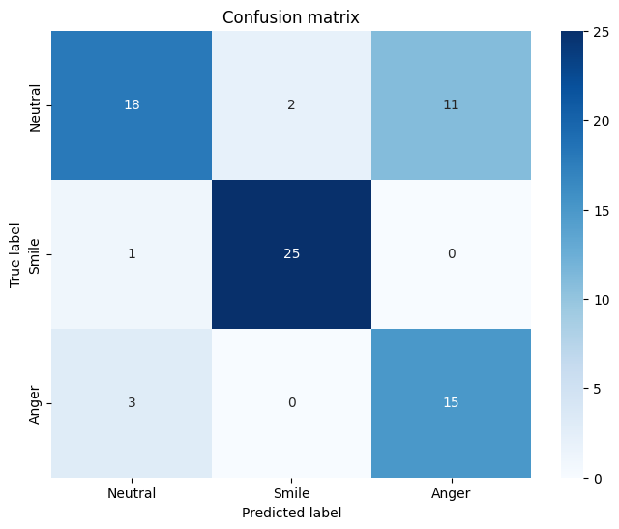

**5.4.3** *Confusion Matrix of Naïve Bayes*:

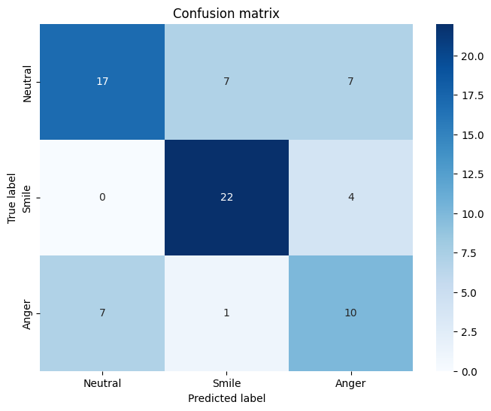

**5.4.4** *Confusion Matrix of Decision Tree*:

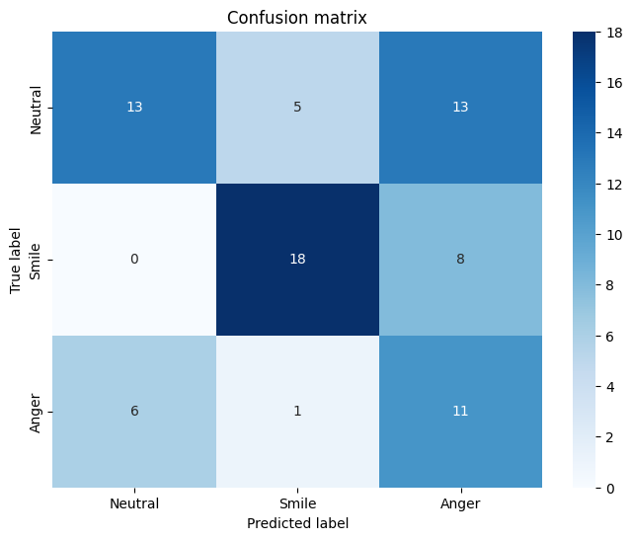

**5.4.5** *Confusion Matrix of Support Vector Machine (SVM)*:

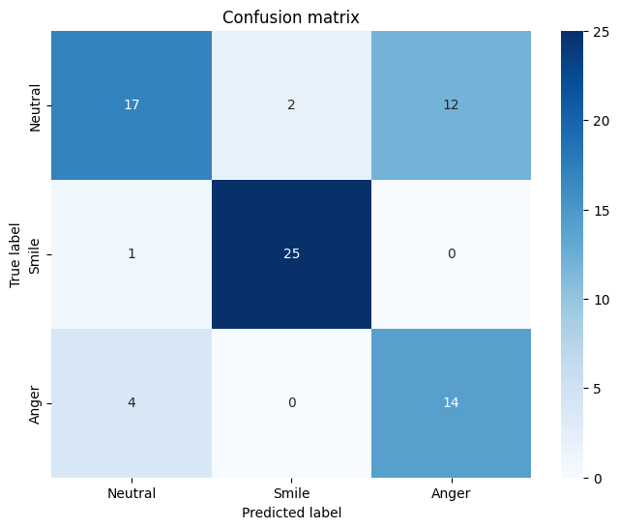

***(ADDITIONAL CLASSIFIERS)***

**5.4.6** *Confusion Matrix of Random Forest*:

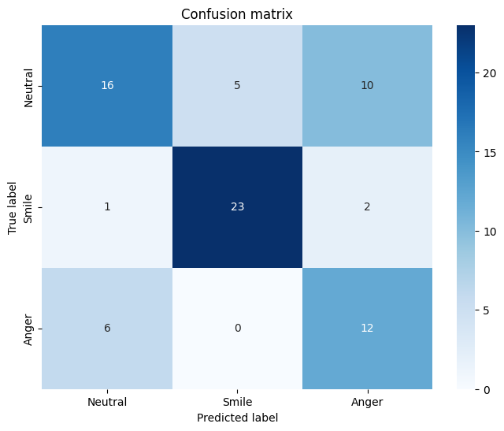

**5.4.7** *Confusion Matrix of Logistic Regression*:

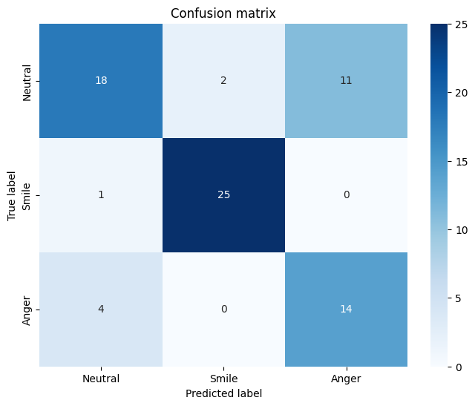

**5.5 Discussion:**

The above results shows that the ANN comprehensively was the most effective classifier for accuracy, precision, and the recall. These results emphasizes that ANNs are especially well-suited for challenging pattern recognition tasks, where it's critical to capture even the smallest deviations in the data, like face expression identification. Additionally, the SVM outperformed the ANN, particularly in terms of precision and recall. This makes it a trustworthy substitute for ANN. The performance of the k-NN and naive Bayes classifiers was comparable, albeit moderate by all measures. This implies that although they might be helpful for easier tasks, they would not work as well on datasets with greater complexity, such detecting facial expressions. The tendency of the Decision Tree classifier to overfit the training set, which results in poorer generalization on unobserved data, is the cause of its lower performance. This implies that although they might be helpful for easier tasks, they would not work as well on datasets with greater complexity, such detecting facial expressions. The tendency of the Decision Tree classifier to overfit the training set, which results in poorer generalization on unobserved data, is the cause of its lower performance. This suggests that in order to enhance its performance in these kinds of tasks, more advanced strategies or regularization techniques could be needed.

The findings imply that while more complicated models like ANN and SVM perform better for face expression recognition tasks, simpler classifiers can deliver speedy and reasonably accurate solutions. These results are essential for choosing suitable models in practical situations where dependability and precision are critical.

1. **CONCLUSION**

Using the AR face database, this study effectively illustrated the use of several machine learning classifiers for facial emotion identification. We developed and assessed five (5) classifiers which are Artificial Neural Network (ANN), Naive Bayes Classifier, the k-Nearest Neighbour (k-NN) Classifier, Support Vector Machine (SVM) and the Decision Tree by extracting different features from Images obtained from AR Face Database.

The best classifier for this challenge, according to the results, was ANN since it had the maximum accuracy, precision, and recall. SVM fared well as well, particularly in terms of recall and precision, suggesting that it is a good choice for facial expression recognition. The Decision Tree classifier had the worst performance, probably as a result of overfitting, whereas Naive Bayes and k-NN had reasonable performance.

These findings underscore the importance of selecting appropriate classifiers based on the complexity of the dataset and the specific requirements of the task. For tasks requiring high accuracy and reliability in facial expression recognition, complex models like ANN and SVM are recommended. This study provides valuable insights for future research and development in the field of facial expression recognition, particularly in applications related to human-computer interaction, security, and psychological studies.